Interface requirments

Author(s)*:* SESA710169

Published on: 17-Jul-2023

Table of Contents

Chapter 1: Requirement Set: Interface requirments 2

1 M12 -> PNP Input 3

2 Deutsch 6 pin -> CANJ Input 3

3 Direct to network Connector 5

4 RTU -> Modbus Splitter Box 5

5 RTU -> Ethernet Splitter Box 6

6 RTU -> Profinet Splitter Box 6

7 Sensor -> Io Link Master 6

Appendix 9

Artifact List 9

Chapter 1: Requirement Set: Interface requirments

Description

Implementation Status

Total: 7, Implemented: 3, Justified: 0, None: 4

Verification Status

Total: 7, Passed: 0, Justified: 0, Failed: 0, Unexecuted: 0, None: 7

Change Information No change issue detected.

1 M12 -> PNP Input

Requirement Type Functional

ID Connector - PNP Sensor

Description

Change Information No change issue detected.

Implementation Status

Total: 1, Implemented: 0, Justified: 0, None: 1

Verification Status

Total: 1, Passed: 0, Justified: 0, Failed: 0, Unexecuted: 0, None: 1

2 Deutsch 6 pin -> CANJ Input

Requirement Type Functional

ID Connector - CANJ Sensor

Description

Deutsch 6-pin connector for this product with only 5 pins: 24V, 0V, Shield, CAN+, CAN- One pin is not used

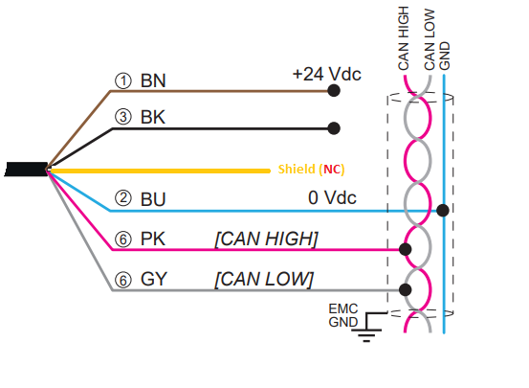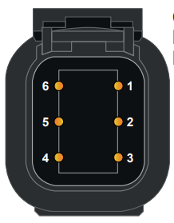

Change Information No change issue detected.

Links

Artifact: Blupanda.slx

|  |  |
| --- | --- |
| Linked Item | Link Type |
| [Deutsch 6-pin Connector](http://127.0.0.1:31415/matlab/feval/rmiobjnavigate?arguments=%5b%22Blupanda.slx%22,%22:372%22%5d) | Implemented by |

Implementation Status

Total: 1, Implemented: 1, Justified: 0, None: 0

Verification Status

Total: 1, Passed: 0, Justified: 0, Failed: 0, Unexecuted: 0, None: 1

3 Direct to network Connector

Requirement Type Functional

ID Connector - Ethernet TCP/IP

Description

Change Information No change issue detected.

Links

Artifact: Blupanda.slx

|  |  |
| --- | --- |
| Linked Item | Link Type |
| [XGSZ 84 EIP](http://127.0.0.1:31415/matlab/feval/rmiobjnavigate?arguments=%5b%22Blupanda.slx%22,%22:8%22%5d) | Implemented by |
| [XGCS 850C 201](http://127.0.0.1:31415/matlab/feval/rmiobjnavigate?arguments=%5b%22Blupanda.slx%22,%22:238%22%5d) | Implemented by |

Implementation Status

Total: 1, Implemented: 1, Justified: 0, None: 0

Verification Status

Total: 1, Passed: 0, Justified: 0, Failed: 0, Unexecuted: 0, None: 1

4 RTU -> Modbus Splitter Box

Requirement Type Functional

ID Connector - MODBUS Box

Description

s

Change Information No change issue detected.

Implementation Status

Total: 1, Implemented: 0, Justified: 0, None: 1

Verification Status

Total: 1, Passed: 0, Justified: 0, Failed: 0, Unexecuted: 0, None: 1

5 RTU -> Ethernet Splitter Box

Requirement Type Functional

ID Connector - Ethernet Box

Description

Change Information No change issue detected.

Implementation Status

Total: 1, Implemented: 0, Justified: 0, None: 1

Verification Status

Total: 1, Passed: 0, Justified: 0, Failed: 0, Unexecuted: 0, None: 1

6 RTU -> Profinet Splitter Box

Requirement Type Functional

ID Connector - Profinet Box

Description

Change Information No change issue detected.

Implementation Status

Total: 1, Implemented: 0, Justified: 0, None: 1

Verification Status

Total: 1, Passed: 0, Justified: 0, Failed: 0, Unexecuted: 0, None: 1

7 Sensor -> Io Link Master

Requirement Type Functional

ID Connector -IO Link Master

Description

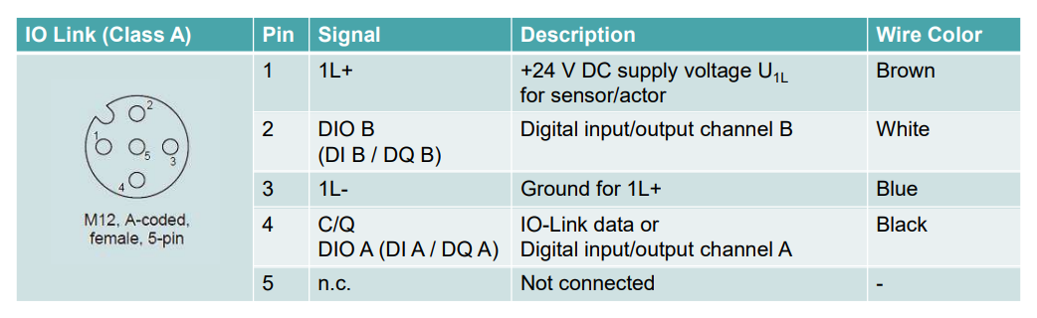

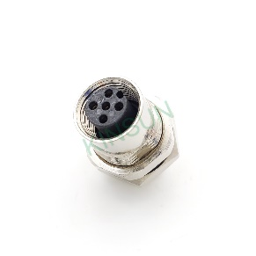

The IO-Link device is coupled with the master using a standard sensor/actuator cable measuring up to 20 m in length.

*From <*[*https://www.sick.com/us/en/io-link-principles-and-technology/w/io-link-basics-and-technology/*](https://www.sick.com/us/en/io-link-principles-and-technology/w/io-link-basics-and-technology/)*>*

Change Information No change issue detected.

Links

Artifact: Blupanda.slx

|  |  |
| --- | --- |
| Linked Item | Link Type |
| [IO Link Cables](http://127.0.0.1:31415/matlab/feval/rmiobjnavigate?arguments=%5b%22Blupanda.slx%22,%22:377%22%5d) | Implemented by |
| [IO Link Cables_1](http://127.0.0.1:31415/matlab/feval/rmiobjnavigate?arguments=%5b%22Blupanda.slx%22,%22:418%22%5d) | Implemented by |
| [XGCS 850C 201](http://127.0.0.1:31415/matlab/feval/rmiobjnavigate?arguments=%5b%22Blupanda.slx%22,%22:238%22%5d) | Implemented by |
| [XGCS 850C 201](http://127.0.0.1:31415/matlab/feval/rmiobjnavigate?arguments=%5b%22Blupanda.slx%22,%22:238%22%5d) | Implemented by |
| [XGCS 850C 201](http://127.0.0.1:31415/matlab/feval/rmiobjnavigate?arguments=%5b%22Blupanda.slx%22,%22:238%22%5d) | Implemented by |
| [XGCS 850C 201](http://127.0.0.1:31415/matlab/feval/rmiobjnavigate?arguments=%5b%22Blupanda.slx%22,%22:238%22%5d) | Implemented by |

Implementation Status

Total: 1, Implemented: 1, Justified: 0, None: 0

Verification Status

Total: 1, Passed: 0, Justified: 0, Failed: 0, Unexecuted: 0, None: 1

Appendix

Artifact List

Simulink models:

|  |  |  |  |
| --- | --- | --- | --- |
| # | Name | Folder | Version |
| 1 | Blupanda.slx | C:\Users\SESA710169\Schneider Electric\Projects\BluePanda\Architecture | 1.87 |